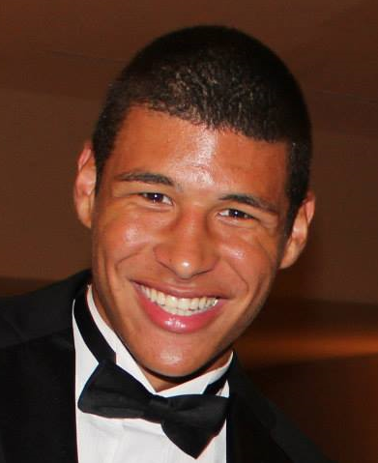

Marcus Domingo, Math

Marcus has been a tutor with the Manassas Math Center for just over a year. He is the vice president of Student Government Association as well as a member of the Manassas Math Club. He competed on the Manassas Math Competition Team for two years in a row. He also earned the award for Academic Excellence in Spring 2014 while attending NOVA. He is able to tutor almost any math level from MTH 151 to MTH 272. His available hours are 2-7pm on Tuesdays and 10am-1pm on Wednesdays for the Spring 2015 semester.